# Scope of change

**Affected Systems/Applications:** Perfection, Perfection database

**Affected NOD Locations:** All

**Affected Departments:** Supply Chain, Customer Service, eBusiness

**Time/Date of Change:** Wednesday, March 3, 2021 after 5 p.m. Eastern

**Purpose:** To enhance contingency location functionality, National Oak’s IT Department will be changing the Perfection system to add a new field and change messaging. Changes will also be made to the Perfection database (Rave references for ecommerce customer information) and the BI database.

**Steps users must take to see this change:** There is no downtime associated with this change. Users do not need to take any action.

# Description of change

## Perfection field change

Currently, when orders need to be diverted from a warehouse, the Business must request the IT Department change the location’s Use Contingency Location flag - 10.2.6.2 field 112 – to **Y**. This diverts that location’s customers to their contingency locations.

In order to support multiple scenarios when a small group of customers need to be diverted to their contingency location and to allow the Business to make that change, a new field is being added to **Customer Entry 6.1.1**. The new field is **106 Use Contingency Loc**.

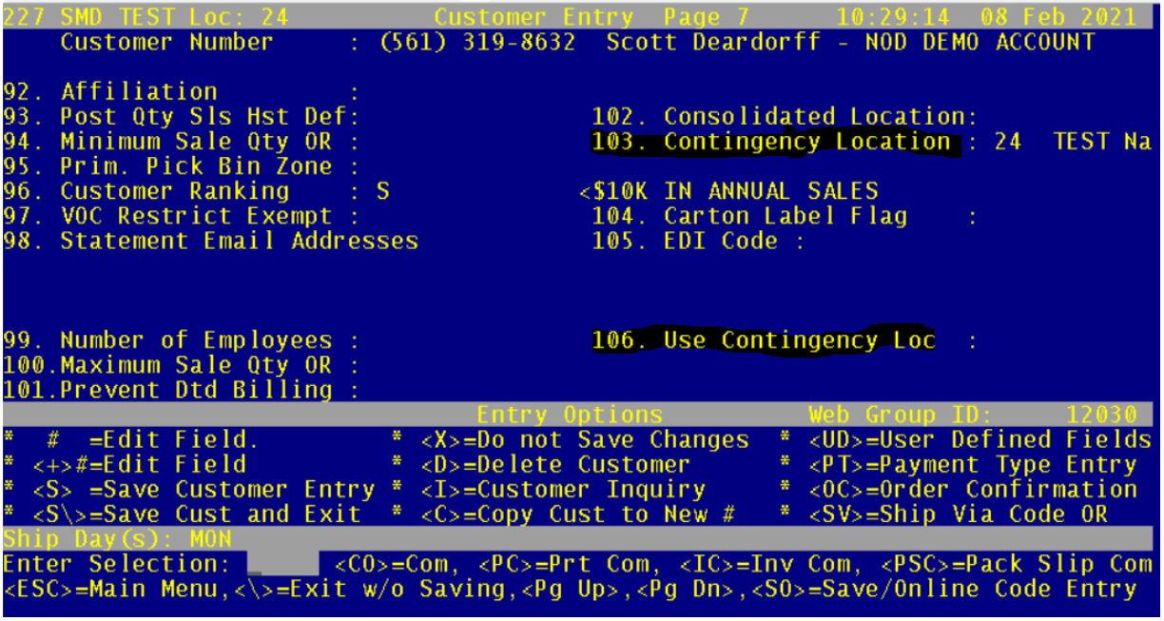

When field 106 is empty, the customer defaults to the location’s Contingency Location field at 10.2.6.2 field 112.

When field 106 is set to **Y**, the customer’s orders will divert to the contingency location specified in **field 103**.

If field 103 is blank, customer’s orders will default to their regular servicing location.

## Perfection messaging change

When the customer has been diverted to their contingency location, any orders started in a different location will prompt the CSR that the order location and contingency location do not match.

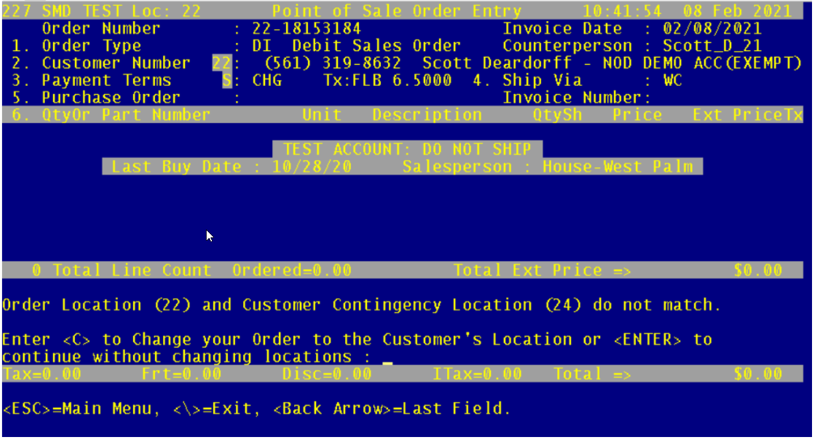

## Perfection database changes

When an ecommerce customer is diverted to their contingency location, calls for “Customer Info” will return the customer's contingency location. Calls for “Quantity on Hand by Customer” will hide the customer’s primary warehouse inventory.

The following database procedures will no longer be used and will be deleted:

* sp_nod_ecommerce_qohforpart
* sp_nod_ecommerce_qohforpartextendedinfo

## BI database changes

Two fields have been added to the Customers table:

* ContingencyWarehouse_ID
* UseContingencyWarehouseFlag

The source for these fields are detailed in the BI data table PerfectionXRefs. Customer Load Map info is detailed in vwCustomerLoadTemplateXRefs.

# Reference Material

## Related Documentation

SOP-EXE-003-C Order Diversion